**Badshahi Mosque Photo Frame**

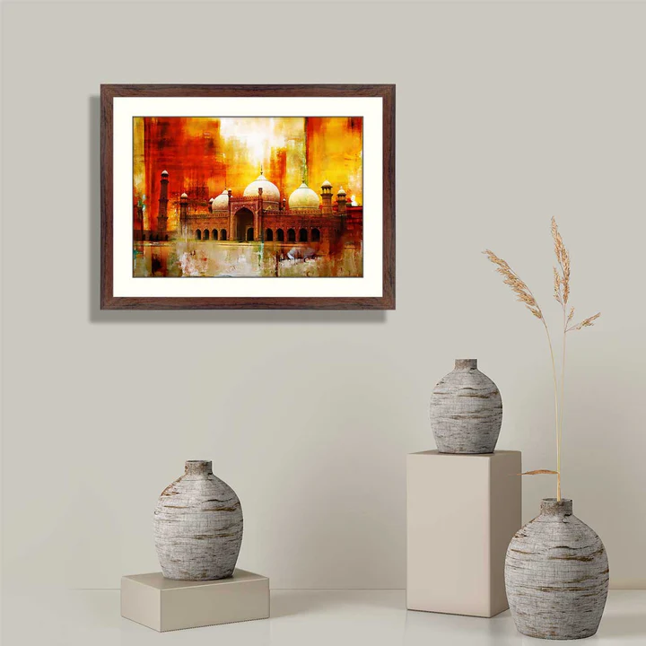A Badshahi Mosque photo frame is a stunning tribute to one of the most iconic architectural marvels in the world. Featuring the grandeur of this 17th-century Mughal masterpiece, the frame captures the mosque’s intricate details, including its majestic domes, minarets, and expansive courtyard. Encased in a sleek and elegant frame, this piece is perfect for adding a touch of cultural heritage and timeless beauty to your living space, office, or gallery. Ideal for admirers of Islamic architecture and history, it serves as both a decorative piece and a celebration of South Asian artistry.